Architecture Document
- Application
Sprint 3 focuses on improving the performance and reliability of the analytics API as well as implementing continuous integration and deployment monitoring. The system reacts to different operational events such as API requests, cache operations, CI pipeline triggers, deployments, and monitoring alerts.
For this sprint, an Event-Driven Architecture is used. In this architecture, different components of the system respond to events generated during runtime or during the development pipeline. For example, an analytics request from a user triggers the API processing module, which checks the Redis cache before computing analytics results. If the requested data is already cached, the response is returned quickly. Otherwise, the analytics processing module calculates the result and stores it in the cache for future requests.
Similarly, development workflow activities are also event-driven. When a developer pushes code to the repository, a CI pipeline is triggered automatically. The pipeline runs automated tests and generates coverage reports. When a new version of the system is deployed to the staging environment, smoke tests are triggered to verify that the ingestion and analytics workflows operate correctly.
Monitoring tools continuously track system logs, response times, and failures. If abnormal conditions occur, the monitoring system generates alerts so that developers can quickly respond to issues.
The architecture contains the following major modules:
  - Analytics API Module
Handles analytics requests from the frontend, validates parameters, performs pagination, and returns analytics results.
  - Redis Cache Module
Stores frequently requested analytics responses to improve performance and reduce repeated computation.
  - Rate Limiting Module
Prevents excessive API usage by limiting the number of requests allowed in a given time window.
  - CI Pipeline Module
Automatically runs tests and generates coverage reports whenever code is pushed to the repository.
  - Smoke Testing Module
Runs validation tests after staging deployment to ensure the ingest-to-analytics workflow works correctly.
  - Monitoring and Alerting Module
Collects logs and system metrics and generates alerts when failures or abnormal performance patterns are detected.
  - This architecture ensures that analytics requests, deployments, and monitoring activities are handled efficiently through event-driven interactions between system components.
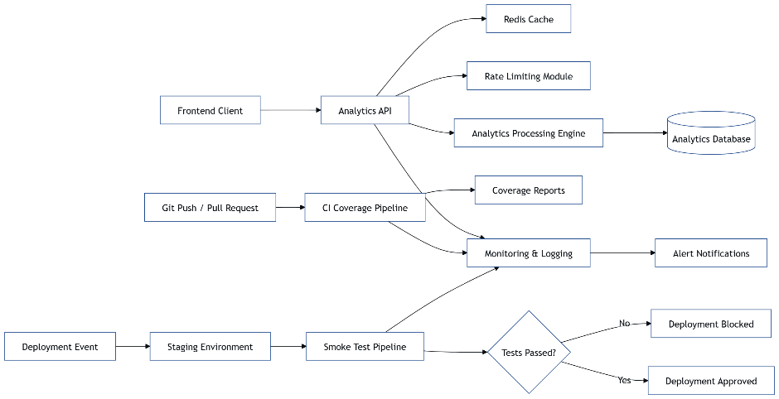

- Database
  - ER Diagram
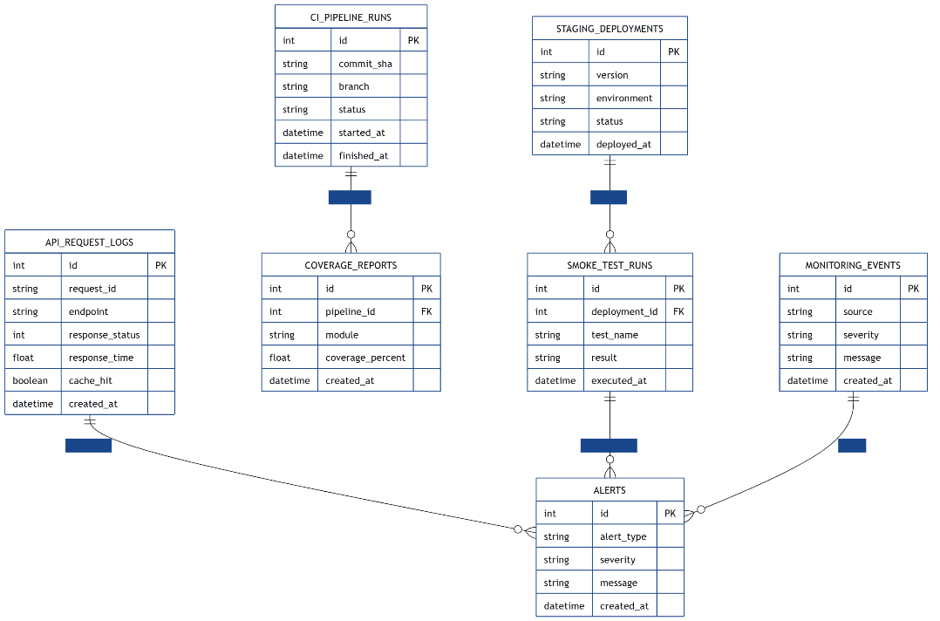
  - Schema Design
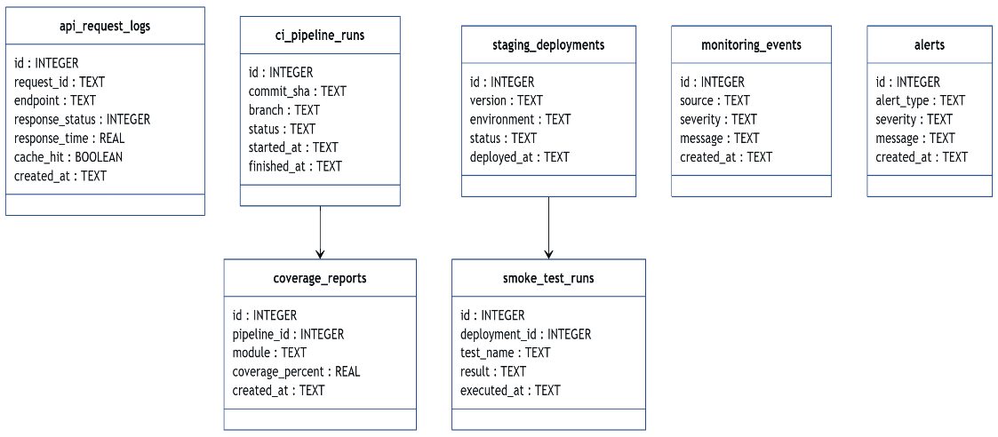
- Data Exchange Contract
  - Frequency of data exchanges
Different components exchange data at different times:
    - Analytics API Requests
Occur whenever users query analytics data from the frontend.
    - Cache Operations
Executed for every analytics request to check whether a cached result already exists.
    - CI Pipeline Execution
Triggered whenever developers push code or create pull requests.
    - Coverage Report Generation
Occurs after successful CI test execution.
    - Staging Deployment
Executed when a new application version is deployed to the staging environment.
    - Smoke Test Execution
Triggered automatically after staging deployment.
    - Monitoring Events
Generated continuously based on system logs and performance metrics.
    - Alert Dispatch
Occurs when system failures or abnormal performance metrics are detected.

  - Data Sets
The system exchanges several types of data during operation.
    - Analytics Query Data
Parameters and filters used by the frontend to request analytics information.
    - Cached Analytics Results
Stored responses in Redis used to improve API performance.
    - API Request Logs
Records of API requests including response time and status.
    - CI Test Results
Information about test execution and build status from the CI pipeline.
    - Coverage Reports
Code coverage results generated after automated testing.
    - Smoke Test Results
Validation results confirming whether system workflows function correctly after deployment.
    - Monitoring Metrics
System logs, error messages, and performance statistics.
    - Alert Events
Notifications generated when failures or threshold violations occur.

  - Mode of Exchanges (API, File, Queue etc.,)
The system uses several communication mechanisms.
    - REST APIs (JSON)
Used for communication between the frontend client and analytics backend.
    - Redis Cache Protocol
Used by the backend service to store and retrieve cached analytics results.
    - CI Workflow Events
Triggered automatically by Git repository events such as code pushes or pull requests.
    - File Artifacts
Used to store coverage reports generated during CI pipeline execution.
    - Script Execution
Used to run smoke tests after deployment in the staging environment.
    - Monitoring and Alert Notifications
Alerts are delivered through email, webhooks, or messaging systems when system issues are detected.

